Sleep Health Analysis
How lifestyle factors affect sleep quality and disorders
Katie Northrup

Abstract
This project investigates the relationship between lifestyle factors, demographic characteristics, and sleep outcomes using regression modeling. Analyzing a dataset of 374 adults, I employed linear regression to predict sleep quality on a continuous 1–10 scale and logistic regression to predict sleep disorder presence as a binary outcome. Results indicate that stress level is the strongest predictor of sleep quality, with each unit increase associated with a 0.496-point decrease in sleep quality (p < 0.001). Body mass index (BMI) category emerged as the dominant predictor of sleep disorders, with overweight or obese individuals having 45.98 times higher odds of a sleep disorder compared to normal-weight individuals (p < 0.001). The linear model explained 94.1% of variance in sleep quality, while the logistic model achieved 90.6% classification accuracy. These findings suggest distinct intervention strategies, including stress reduction for improving daily sleep quality and weight management for preventing chronic sleep disorders.
Introduction
Sleep constitutes approximately one-third of human life and plays a critical role in physiological restoration, cognitive function, and overall health. Poor sleep quality and sleep disorders are associated with increased risks of cardiovascular disease, metabolic dysfunction, mental health disorders, and reduced quality of life. Despite growing awareness, the specific lifestyle factors that most significantly impact sleep outcomes remain inadequately quantified in clinical and public health contexts. This project addresses two complementary research questions using regression modeling approaches: what lifestyle and demographic factors predict sleep quality scores, and can we accurately predict sleep disorder risk from measurable lifestyle factors?
I selected ordinary least squares (OLS) regression for the continuous sleep quality outcome and binary logistic regression for the dichotomous sleep disorder outcome. These methods were chosen based on the measurement scales of the response variables and the interpretability requirements for clinical and public health applications. While sleep quality is technically measured on an ordinal 1–10 scale, I chose linear regression over ordinal logistic regression for three key reasons. The scale approximates interval measurement with approximately equal spacing between points, diagnostic plots revealed linear relationships with predictors, and OLS provides more interpretable coefficient estimates for practical application. By examining both continuous and binary sleep outcomes, this analysis provides a comprehensive understanding of sleep health determinants.
Research Questions
- What factors influence sleep quality scores?
- Can we predict sleep disorder risk from lifestyle?
Data Description and EDA
I utilized the Sleep Health and Lifestyle Dataset from Kaggle, comprising 374 complete observations after data cleaning. The dataset includes demographic variables such as age ranging from 27 to 59 years and gender, lifestyle factors including stress level on a 3–8 scale, physical activity level measured in minutes per day, and daily steps, health indicators such as BMI category and heart rate, and sleep outcomes including sleep quality on a 1–10 scale and sleep disorder classification.
My visual exploration revealed several key patterns that informed subsequent modeling decisions. A scatterplot of stress versus sleep quality showed a strong negative linear relationship, with a correlation coefficient of approximately −0.85, indicating that higher stress is consistently associated with lower sleep quality. Boxplots comparing BMI categories against sleep quality demonstrated monotonic decreases in sleep quality across BMI groups, with the largest reductions observed in overweight and obese individuals. Physical activity showed weak positive associations with sleep quality, while daily steps exhibited a similar but weaker relationship. The distribution of sleep disorders revealed substantial class imbalance, with most disorders concentrated in overweight and obese individuals. This pattern became critically important when fitting the logistic regression model because it initially created issues with complete separation. All analyses were conducted in R using packages including tidyverse, car, broom, effects, and nnet.
Model Building and Methodology
For predicting sleep quality, I compared two linear regression specifications. The full model included stress, activity level, daily steps, heart rate, age, gender, and BMI category, while the reduced model contained only stress, age, gender, and BMI. The full model demonstrated significantly better fit, explaining 94.1% of variance in sleep quality compared to 92.6% for the reduced model (see Appendix for complete model outputs). An ANOVA test confirmed this improvement was statistically significant (F(3,364) = 30.07, p < 0.001). Although variance inflation factors indicated some multicollinearity among predictors in the full model, I retained it based on theoretical importance and superior predictive performance.
For predicting sleep disorders, I converted the categorical sleep disorder variable into a binary outcome and encountered complete separation in the initial modeling attempt, with all obese individuals having sleep disorders. To address this statistical issue, I collapsed BMI categories into two groups: normal, combining normal and normal weight, and overweight or obese, combining overweight and obese. I compared logistic regression models with and without physical activity and ultimately selected the simpler model based on parsimony principles. Physical activity was statistically non-significant (p = 0.641) and did not meaningfully improve model fit according to likelihood ratio testing (χ²(1) = 0.22, p = 0.638). I also explored interaction terms between stress and BMI category, but these terms were not statistically significant and did not improve model fit based on AIC, so they were excluded from the final models for interpretability.
Results
The final linear regression model revealed several statistically significant predictors of sleep quality. Stress emerged as the strongest negative predictor, with each one-unit increase associated with a 0.496-point decrease in sleep quality (p < 0.001). Age showed a positive relationship, with each additional year associated with a 0.057-point increase in sleep quality (p < 0.001). Gender differences were apparent, with males reporting sleep quality scores 0.290 points higher than females on average (p < 0.001). BMI categories demonstrated substantial effects, with obese individuals showing 0.954-point lower sleep quality and overweight individuals showing 0.921-point lower sleep quality compared to normal-weight individuals (both p < 0.001). Physical activity and daily steps showed small but statistically significant positive effects (p = 0.018 and p = 0.044, respectively).
The logistic regression model for sleep disorders produced markedly different patterns of predictor importance. BMI category dominated the model, with overweight or obese individuals having odds of sleep disorders that were 45.98 times higher than normal-weight individuals (p < 0.001). Stress showed a more modest effect, with each unit increase associated with 52.4% higher odds of a sleep disorder (p = 0.005). Age exhibited a small positive effect that approached but did not reach conventional statistical significance (p = 0.065), while gender differences were not statistically significant in this model (p = 0.124). The final logistic model demonstrated strong classification performance, achieving 90.6% overall accuracy with 89.7% sensitivity and 91.3% specificity.
My model diagnostics provided assurance regarding model assumptions. For the linear model, residual analysis revealed some deviation from perfect normality in the tails (Shapiro–Wilk p < 0.001), but the central distribution approximated normality reasonably well. Homoscedasticity assumptions appeared satisfied based on visual inspection of residual plots, and no observations exerted undue influence on parameter estimates, with all Cook’s distances below 0.5. For the logistic model, goodness-of-fit testing indicated adequate model specification (Hosmer–Lemeshow p = 0.512), and partial residual plots confirmed approximately linear relationships between continuous predictors and the log-odds of the outcome.
Visualization and Interpretation
The effect plots I created provide intuitive visualization of key relationships identified in the models (see Appendix for figures). For the linear model, the effect of stress on sleep quality appears as a smooth downward line, reflecting the consistent negative relationship captured by the regression coefficient. In the logistic model, the effect plot for stress shows a straight line on the log-odds scale, which represents the linear relationship assumed by logistic regression between predictors and the log-odds of the outcome. While the underlying probability curve follows a sigmoidal shape, the linear approximation is valid across the observed range of stress values in my dataset, where predicted probabilities fall between approximately 0.2 and 0.8. This explains why the plotted effect appears linear rather than sigmoidal.
Discussion
My analysis reveals differential predictor importance for sleep quality versus sleep disorders. Stress dominates sleep quality prediction, while BMI dominates sleep disorder prediction. This pattern suggests potentially distinct underlying mechanisms. Stress may primarily affect daily sleep physiology and subjective sleep experience, while BMI may contribute to structural or physiological changes that predispose individuals to clinical sleep disorders. The effect sizes I observed are clinically meaningful. For instance, a stress reduction from 8 to 5, which is achievable through standard stress management interventions, would improve sleep quality by approximately 1.5 points, representing a noticeable difference in daily functioning. Together, these results directly address the research questions by identifying stress as the primary determinant of sleep quality and BMI category as the strongest predictor of sleep disorder risk.
The gender findings present an interesting paradox. Males report better sleep quality on average but show similar sleep disorder risk compared to females. This pattern could reflect differences in symptom reporting, distinct sleep disturbance phenotypes between genders, or varying expectations about what constitutes good sleep. From a methodological perspective, my handling of complete separation through BMI category collapsing, while statistically necessary, may obscure nuanced differences between overweight and obese individuals that could be important clinically. Future research with larger samples should preserve these distinctions where possible.
Several limitations warrant consideration when interpreting these findings. The cross-sectional design precludes causal inference, and bidirectional relationships are plausible. For example, poor sleep may increase stress levels, creating a feedback loop. Self-report measures introduce potential bias, particularly for subjective constructs like sleep quality. The sample lacks diversity in certain demographic dimensions, which limits generalizability. Finally, unmeasured confounding factors such as mental health conditions, medication use, or environmental factors could influence the observed relationships.
Conclusion and Implications
My analysis demonstrates that sleep quality and sleep disorders have distinct but overlapping predictors, with stress reduction emerging as the primary lever for improving subjective sleep quality and weight management appearing crucial for preventing clinical sleep disorders. These findings carry practical implications for healthcare providers, suggesting that BMI screening should be integrated into sleep disorder assessment protocols and that tailored interventions may be needed, including stress management for those with sleep quality complaints and weight management for those at risk of sleep disorders. For researchers, the study highlights the value of examining multiple sleep outcomes simultaneously and provides a regression modeling framework that balances statistical rigor with clinical interpretability. Future research should employ longitudinal designs to establish temporal precedence, incorporate objective sleep measures to complement self-report data, and test interventions that simultaneously address both stress and weight factors to optimize sleep health outcomes.
References
Dataset Source: https://www.kaggle.com/datasets/minahilfatima12328/lifestyle-and-sleep-patterns
Faraway, J. J. (2016). Extending the Linear Model with R (2nd ed.). Chapman & Hall/CRC
Kutner, M. H., Nachtsheim, C. J., Neter, J., & Li, W. (2005). Applied Linear Statistical Models (5th ed.). McGraw-Hill/Irwin
Appendix
R Code and Graphs
# 1. DATA LOADING AND PREPARATION
setwd("C:/Users/katie/Downloads")
df <- read_csv("Sleep_health_and_lifestyle_dataset.csv")
df <- df %>%
rename(
SleepDuration = `Sleep Duration`,
SleepQuality = `Quality of Sleep`,
Activity = `Physical Activity Level`,
Stress = `Stress Level`,
BMI = `BMI Category`,
SleepDisorder = `Sleep Disorder`,
Steps = `Daily Steps`,
HeartRate = `Heart Rate`
) %>%
mutate(
Gender = factor(Gender),
Occupation = factor(Occupation),
BMI = factor(BMI),
SleepDisorder = factor(SleepDisorder),
SleepQuality = as.numeric(SleepQuality),
SleepDuration = as.numeric(SleepDuration),
Stress = as.numeric(Stress),
Activity = as.numeric(Activity),
Steps = as.numeric(Steps),
HeartRate = as.numeric(HeartRate)
) %>%
drop_na()
dim(df) # Dataset dimensions
## [1] 374 13
# 2. EXPLORATORY DATA ANALYSIS
ggplot(df, aes(Stress, SleepQuality)) +
geom_point(alpha=0.5) +
geom_smooth(method="lm") +
theme_minimal() +
labs(title="Relationship Between Stress and Sleep Quality")
## `geom_smooth()` using formula = 'y ~ x'
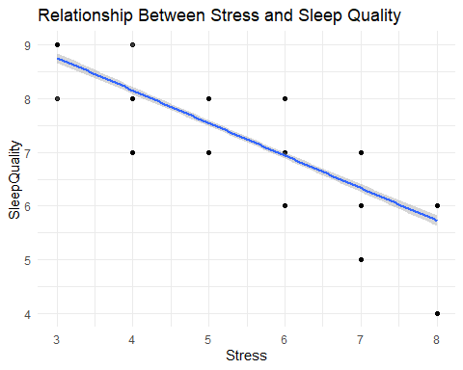
ggplot(df, aes(Activity, SleepQuality)) +
geom_point(alpha=0.5) +
geom_smooth(method="lm") +
theme_minimal() +
labs(title="Effect of Physical Activity on Sleep Quality")
## `geom_smooth()` using formula = 'y ~ x'
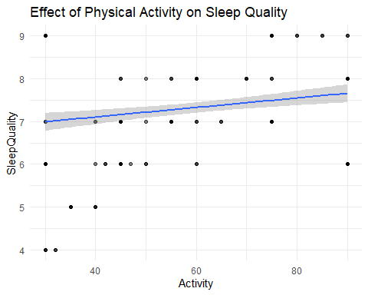
ggplot(df, aes(SleepDisorder)) +
geom_bar() +
theme_minimal() +
labs(title="Distribution of Sleep Disorder Categories")
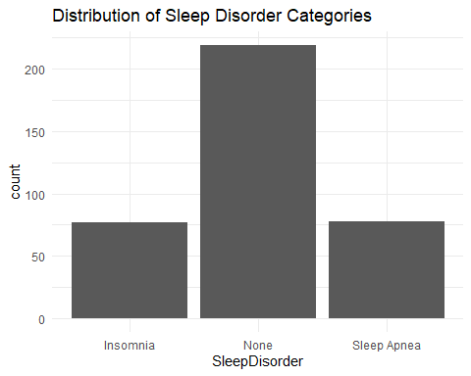
ggplot(df, aes(BMI, SleepQuality, fill = BMI)) +
geom_boxplot() +
theme_minimal() +
labs(title="Sleep Quality by BMI Category") +
theme(legend.position = "none")
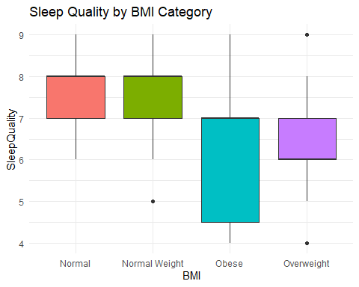
numeric_vars <- df %>%
dplyr::select(SleepQuality, SleepDuration, Stress, Activity, Steps, HeartRate, Age)
GGally::ggpairs(numeric_vars)
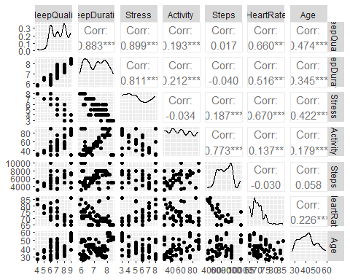
# 3. LINEAR MODEL FOR SLEEP QUALITY
lm1 <- lm(SleepQuality ~ Stress + Activity + Steps + HeartRate + Age + Gender + BMI, data = df)
summary(lm1)
##
## Call:
## lm(formula = SleepQuality ~ Stress + Activity + Steps + HeartRate +
## Age + Gender + BMI, data = df)
##
## Residuals:
## Min 1Q Median 3Q Max
## -0.92066 -0.15354 -0.02144 0.15308 1.19654
##
## Coefficients:
## Estimate Std. Error t value Pr(>|t|)
## (Intercept) 6.804e+00 6.123e-01 11.113 < 2e-16 ***
## Stress -4.955e-01 2.149e-02 -23.057 < 2e-16 ***
## Activity 4.021e-03 1.698e-03 2.369 0.0184 *
## Steps 4.484e-05 2.215e-05 2.025 0.0436 *
## HeartRate 6.833e-03 9.503e-03 0.719 0.4726
## Age 5.699e-02 2.819e-03 20.215 < 2e-16 ***
## GenderMale 2.898e-01 4.350e-02 6.662 1.00e-10 ***
## BMINormal Weight -1.209e-01 7.154e-02 -1.691 0.0918 .
## BMIObese -9.538e-01 1.605e-01 -5.942 6.58e-09 ***
## BMIOverweight -9.212e-01 4.567e-02 -20.172 < 2e-16 ***
## ---
## Signif. codes: 0 '***' 0.001 '**' 0.01 '*' 0.05 '.' 0.1 ' ' 1
##
## Residual standard error: 0.2946 on 364 degrees of freedom
## Multiple R-squared: 0.9409, Adjusted R-squared: 0.9394
## F-statistic: 643.9 on 9 and 364 DF, p-value: < 2.2e-16
car::vif(lm1)
## GVIF Df GVIF^(1/(2*Df))
## Stress 6.251878 1 2.500376
## Activity 5.375285 1 2.318466
## Steps 5.519396 1 2.349339
## HeartRate 6.639903 1 2.576801
## Age 2.570235 1 1.603195
## Gender 2.039110 1 1.427974
## BMI 5.886067 3 1.343706
lm2 <- lm(SleepQuality ~ Stress + Age + Gender + BMI, data = df)
summary(lm2)
##
## Call:
## lm(formula = SleepQuality ~ Stress + Age + Gender + BMI, data = df)
##
## Residuals:
## Min 1Q Median 3Q Max
## -1.07559 -0.22695 0.05633 0.18723 1.13882
##
## Coefficients:
## Estimate Std. Error t value Pr(>|t|)
## (Intercept) 7.465663 0.167323 44.618 < 2e-16 ***
## Stress -0.469559 0.012644 -37.136 < 2e-16 ***
## Age 0.062179 0.003067 20.275 < 2e-16 ***
## GenderMale 0.314234 0.044940 6.992 1.29e-11 ***
## BMINormal Weight -0.091085 0.076848 -1.185 0.237
## BMIObese -1.034783 0.106724 -9.696 < 2e-16 ***
## BMIOverweight -0.943185 0.049237 -19.156 < 2e-16 ***
## ---
## Signif. codes: 0 '***' 0.001 '**' 0.01 '*' 0.05 '.' 0.1 ' ' 1
##
## Residual standard error: 0.3277 on 367 degrees of freedom
## Multiple R-squared: 0.9263, Adjusted R-squared: 0.925
## F-statistic: 768.2 on 6 and 367 DF, p-value: < 2.2e-16
anova(lm2, lm1)
## Analysis of Variance Table
##
## Model 1: SleepQuality ~ Stress + Age + Gender + BMI
## Model 2: SleepQuality ~ Stress + Activity + Steps + HeartRate + Age +
## Gender + BMI
## Res.Df RSS Df Sum of Sq F Pr(>F)
## 1 367 39.411
## 2 364 31.585 3 7.8266 30.066 < 2.2e-16 ***
## ---
## Signif. codes: 0 '***' 0.001 '**' 0.01 '*' 0.05 '.' 0.1 ' ' 1
data.frame(Model = c("Full", "Simplified"), AIC = c(AIC(lm1), AIC(lm2)))
## Model AIC
## 1 Full 158.9950
## 2 Simplified 235.7911
par(mfrow=c(2,2))
plot(lm1)
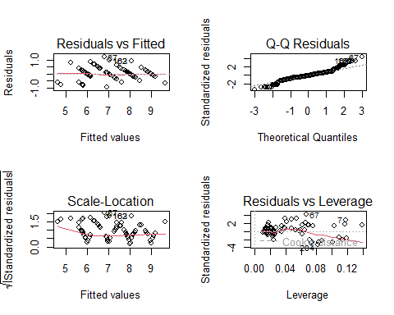
par(mfrow=c(1,1))
shapiro.test(residuals(lm1))
##
## Shapiro-Wilk normality test
##
## data: residuals(lm1)
## W = 0.95131, p-value = 9.03e-10
# 4. LOGISTIC REGRESSION FOR SLEEP DISORDERS
df <- df %>%
mutate(DisorderBinary = ifelse(SleepDisorder == "None", 0, 1))
# Fix separation by combining Overweight and Obese categories
df <- df %>%
mutate(BMI_fixed = case_when(
BMI %in% c("Normal", "Normal Weight") ~ "Normal",
BMI %in% c("Overweight", "Obese") ~ "Overweight/Obese"
),
BMI_fixed = factor(BMI_fixed))
table(df$BMI_fixed, df$DisorderBinary)
##
## 0 1
## Normal 200 16
## Overweight/Obese 19 139
# Logistic regression
logit1_fixed <- glm(DisorderBinary ~ Stress + Activity + Age + Gender + BMI_fixed,
family = binomial, data = df)
summary(logit1_fixed)
##
## Call:
## glm(formula = DisorderBinary ~ Stress + Activity + Age + Gender +
## BMI_fixed, family = binomial, data = df)
##
## Coefficients:
## Estimate Std. Error z value Pr(>|z|)
## (Intercept) -6.715227 1.883807 -3.565 0.000364 ***
## Stress 0.438537 0.159790 2.744 0.006061 **
## Activity 0.004764 0.010215 0.466 0.640949
## Age 0.054647 0.031780 1.720 0.085512 .
## GenderMale -0.798332 0.498495 -1.601 0.109269
## BMI_fixedOverweight/Obese 3.831312 0.410223 9.340 < 2e-16 ***
## ---
## Signif. codes: 0 '***' 0.001 '**' 0.01 '*' 0.05 '.' 0.1 ' ' 1
##
## (Dispersion parameter for binomial family taken to be 1)
##
## Null deviance: 507.47 on 373 degrees of freedom
## Residual deviance: 219.43 on 368 degrees of freedom
## AIC: 231.43
##
## Number of Fisher Scoring iterations: 6
logit2_fixed <- glm(DisorderBinary ~ Stress + Age + Gender + BMI_fixed,
family = binomial, data = df)
summary(logit2_fixed)
##
## Call:
## glm(formula = DisorderBinary ~ Stress + Age + Gender + BMI_fixed,
## family = binomial, data = df)
##
## Coefficients:
## Estimate Std. Error z value Pr(>|z|)
## (Intercept) -6.51306 1.81790 -3.583 0.00034 ***
## Stress 0.42149 0.15031 2.804 0.00504 **
## Age 0.05739 0.03112 1.844 0.06516 .
## GenderMale -0.73541 0.47803 -1.538 0.12395
## BMI_fixedOverweight/Obese 3.82827 0.40794 9.384 < 2e-16 ***
## ---
## Signif. codes: 0 '***' 0.001 '**' 0.01 '*' 0.05 '.' 0.1 ' ' 1
##
## (Dispersion parameter for binomial family taken to be 1)
##
## Null deviance: 507.47 on 373 degrees of freedom
## Residual deviance: 219.65 on 369 degrees of freedom
## AIC: 229.65
##
## Number of Fisher Scoring iterations: 5
anova(logit2_fixed, logit1_fixed, test = "Chisq")
## Analysis of Deviance Table
##
## Model 1: DisorderBinary ~ Stress + Age + Gender + BMI_fixed
## Model 2: DisorderBinary ~ Stress + Activity + Age + Gender + BMI_fixed
## Resid. Df Resid. Dev Df Deviance Pr(>Chi)
## 1 369 219.65
## 2 368 219.43 1 0.22127 0.6381
data.frame(Model = c("With Activity", "Without Activity"),
AIC = c(AIC(logit1_fixed), AIC(logit2_fixed)))
## Model AIC
## 1 With Activity 231.4275
## 2 Without Activity 229.6487
# Choose final logistic model
logit_final <- logit2_fixed
exp(cbind(OR = coef(logit_final), confint(logit_final))) # Odds ratios with CI
## Waiting for profiling to be done...
## OR 2.5 % 97.5 %
## (Intercept) 0.001483928 3.676341e-05 0.04779316
## Stress 1.524234316 1.150529e+00 2.07738157
## Age 1.059071887 9.962393e-01 1.12648249
## GenderMale 0.479307599 1.856701e-01 1.22407635
## BMI_fixedOverweight/Obese 45.982911450 2.141678e+01 106.91074034
pred_logit <- ifelse(predict(logit_final, type="response") > 0.5, 1, 0)
conf_matrix <- table(Predicted = pred_logit, Actual = df$DisorderBinary)
accuracy <- sum(diag(conf_matrix)) / sum(conf_matrix)
sensitivity <- conf_matrix[2,2] / sum(conf_matrix[,2])
specificity <- conf_matrix[1,1] / sum(conf_matrix[,1])
conf_matrix
## Actual
## Predicted 0 1
## 0 200 16
## 1 19 139
data.frame(Accuracy = accuracy, Sensitivity = sensitivity, Specificity = specificity)
## Accuracy Sensitivity Specificity
## 1 0.9064171 0.8967742 0.913242
# 5. EFFECT PLOTS
plot(effects::Effect("Stress", lm1),
main = "Effect of Stress on Sleep Quality (Linear Model)")
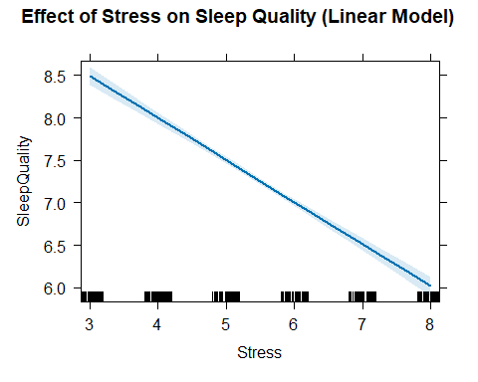
plot(effects::Effect("Stress", logit_final),
main = "Effect of Stress on Probability of Sleep Disorder",
ylab = "Probability", xlab = "Stress Level")
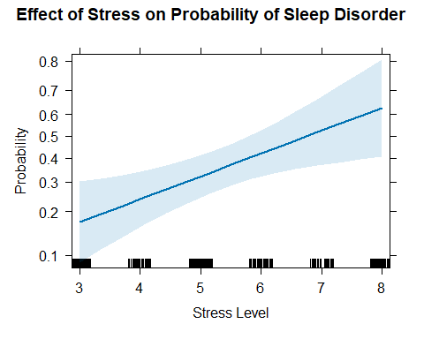
# 6. CLEAN TABLES FOR REPORT
lm1_clean <- broom::tidy(lm1, conf.int = TRUE) %>%
dplyr::select(term, estimate, std.error, conf.low, conf.high, p.value) %>%
mutate(across(where(is.numeric), round, 3))
## Warning: There was 1 warning in `mutate()`.
## ℹ In argument: `across(where(is.numeric), round, 3)`.
## Caused by warning:
## ! The `...` argument of `across()` is deprecated as of dplyr 1.1.0.
## Supply arguments directly to `.fns` through an anonymous function instead.
##
## # Previously
## across(a:b, mean, na.rm = TRUE)
##
## # Now
## across(a:b, \(x) mean(x, na.rm = TRUE))
lm1_clean
## # A tibble: 10 × 6
## term estimate std.error conf.low conf.high p.value
## <chr> <dbl> <dbl> <dbl> <dbl> <dbl>
## 1 (Intercept) 6.80 0.612 5.6 8.01 0
## 2 Stress -0.496 0.021 -0.538 -0.453 0
## 3 Activity 0.004 0.002 0.001 0.007 0.018
## 4 Steps 0 0 0 0 0.044
## 5 HeartRate 0.007 0.01 -0.012 0.026 0.473
## 6 Age 0.057 0.003 0.051 0.063 0
## 7 GenderMale 0.29 0.044 0.204 0.375 0
## 8 BMINormal Weight -0.121 0.072 -0.262 0.02 0.092
## 9 BMIObese -0.954 0.161 -1.27 -0.638 0
## 10 BMIOverweight -0.921 0.046 -1.01 -0.831 0
logit_clean <- broom::tidy(logit_final, conf.int = TRUE, exponentiate = TRUE) %>%
dplyr::select(term, odds_ratio = estimate, conf.low, conf.high, p.value) %>%
mutate(across(where(is.numeric), round, 3))
logit_clean
## # A tibble: 5 × 5
## term odds_ratio conf.low conf.high p.value
## <chr> <dbl> <dbl> <dbl> <dbl>
## 1 (Intercept) 0.001 0 0.048 0
## 2 Stress 1.52 1.15 2.08 0.005
## 3 Age 1.06 0.996 1.13 0.065
## 4 GenderMale 0.479 0.186 1.22 0.124
## 5 BMI_fixedOverweight/Obese 46.0 21.4 107. 0
performance_summary <- data.frame(
Model = c("Linear (Sleep Quality)", "Logistic (Sleep Disorder)"),
R2_Deviance_Explained = c(
round(summary(lm1)$r.squared, 3),
round(1 - (logit_final$deviance/logit_final$null.deviance), 3)
),
AIC = c(round(AIC(lm1), 1), round(AIC(logit_final), 1)),
Accuracy_Classification = c(NA, round(accuracy, 3))
)
performance_summary
## Model R2_Deviance_Explained AIC Accuracy_Classification
## 1 Linear (Sleep Quality) 0.941 159.0 NA
## 2 Logistic (Sleep Disorder) 0.567 229.6 0.906

